THE
PALM VALLEY
REVIEW

Message from the Mayor

Citizens of Palm Valley,

I want to express my heartfelt thanks to the citizens of Palm Valley for re-electing me as your Mayor. I am both humbled and honored that you have placed your trust in me. I am deeply moved by the expression of confidence you bestowed, and I thank you from the bottom of my heart. I am immensely grateful to my wife Sylvia, my many friends, and loyal supporters who so generously contributed their time and effort to our campaign during this year’s elections.
Being an effective leader involves listening to constituents, translating their concerns into workable proposals, and building consensus to implement them. I could not do this job without the involvement and openness of the people I represent. You have taken the time to share with me your ideas, your concerns, and your aspirations, and I sincerely appreciate your willingness to discuss what really matters to you. Not only have you entrusted me with the responsibility of speaking on your behalf, but you also continue to provide me with the ideas and feedback I need to do it as it should be done. For that, I thank you once again.
Our beautiful City faces many challenges, but we can overcome them if we rise above all the politics and do what is best for all of our residents. I look forward to continuing to work for you, as your Mayor, to make the City of Palm Valley a place where people of all ages can count on a future.

Sincerely,
Mayor George Rivera

ELECTION RESULTS OATHS OF OFFICE
The below individuals were administered their Oaths of Office at the council meeting of
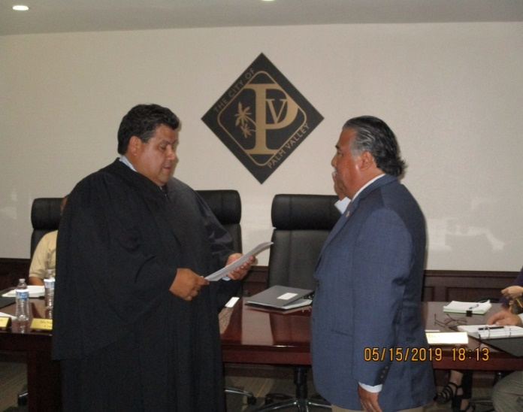
May 15, 2019.
Mayor George Rivera was sworn in by Honorable Judge David Sanchez to serve another 2-year term.

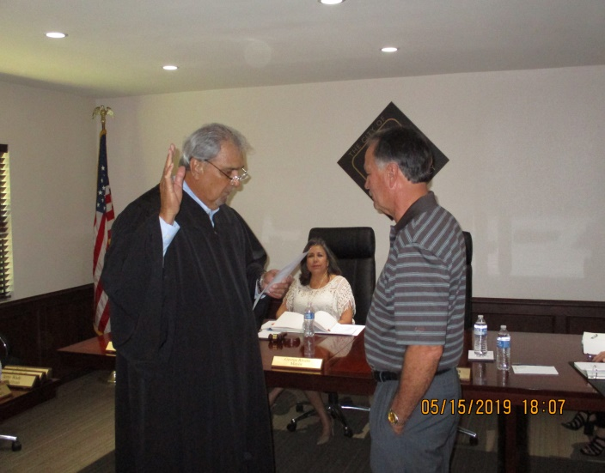
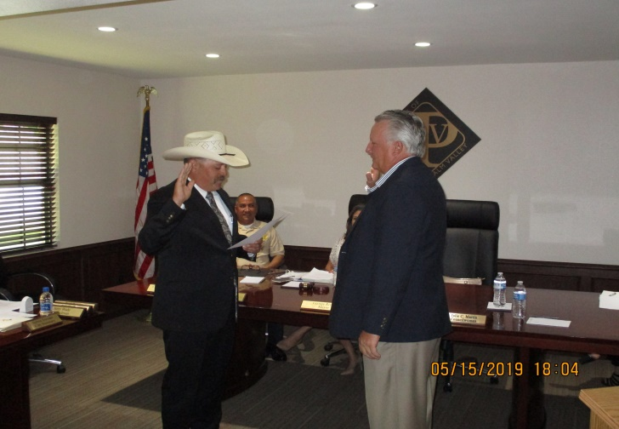
Councilman Eric Hoff was sworn in by Justice of the Peace Mike Trejo to serve his first 2-year term on the Council.

Councilman Jerry Wade was sworn in by Honorable Judge Oscar Guerra to serve a 1-year term on the Council.

MESSAGE FROM THE CHIEF

With Hurricane season beginning June 1st, it is essential that everyone be prepared. Here is a short list of suggestions from texasprepares.org:

Stock up on FOOD & WATER

- 3 day supply of food
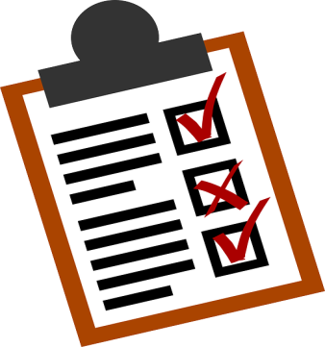
- 1 gallon of water per day per person
Put together FIRST AID KIT & MEDICATIONS

Possess reliable COMMUNICATION & LIGHTING

- Radio with batteries
- Flashlights, candles, matches

Prepare your CAR

- Road maps
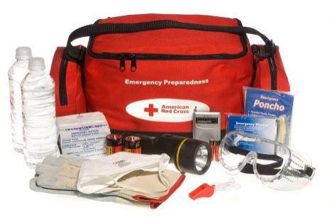
- Car repair tool
- More food & water
Prepare your HOUSE

- Plastic sheeting & duct tape
- Fire extinguisher
Gather PET SUPPLIES

Collect and protect IMPORTANT DOCUMENTS

People with DISABILITIES

- Extra medications
- Cooler with cold packs for meds
- Copies of prescription

SEAL COATING PROJECT

Back in April the City of Palm Valley entered into an interlocal agreement with Cameron County to apply a seal coat to all streets in our City. This was a shared expense project whereby the County provided the equipment and the labor and the City purchased the product. The project is now complete, our streets have a new coat of sealant which will add 5-6 years to the lifespan of our streets. The City of Palm Valley thanks all our residents for their patience during this time where traffic was a challenge through the closing of streets and placement of barricades. Mostly all complied by driving the flow of traffic as directed.

The City also thanks Cameron County. In particular, our County Judge, Eddie Trevino and Precinct 4 County Commissioner, Gus Ruiz who were instrumental in approving this agreement. The City of Palm Valley saved over $150,000 for this project. We are extremely grateful to Cameron County.

The funds for this project came from a special account established by your City Council to specifically address our streets. The account was set up with $100,000 from budget surpluses. City Council authorized the transfer of $44,000 from the “Street Fund” to pay for the product related to this project at their meeting of May 15, 2019.

Hurricane Season – June 1 – Nov 30, 2019
Father’s Day – June 16, 2019
Public Forum – June 17, 2019 - Update & Scope of work for
Lake #3 @ Harlingen Country Club
Fourth of July Parade – July 4, 2019 (Further details TBA)

THE COUNCIL

Mayor: George Rivera
Mayor Pro-Term: Cynthia Thompson
Councilmembers: Lisa Taylor, Michael Galvan, Jerry Wade, and Eric Hoff

City Hall: 423-8384
Municipal Court: 423-8384
Police DPT: 873-1500
Water Services: 423-4040

City’s Website: www.palmvalleytx.com
The next regular City Council meeting is scheduled for

June 12, 2019 at 6:00p.m.
We invite you to attend.

